**P1 C: Create a Pivot Table to analyse and summarize data**

1. Create a pivot table: insert>pivot table 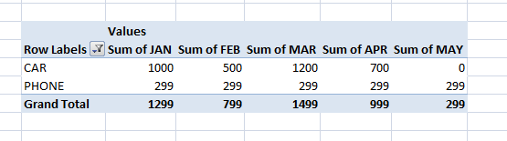
2. Select a cell in the pivot table and go to insert>columns to create a bar diagram 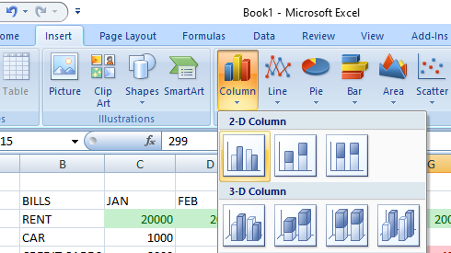
3. Filter the chart and table using the provided options

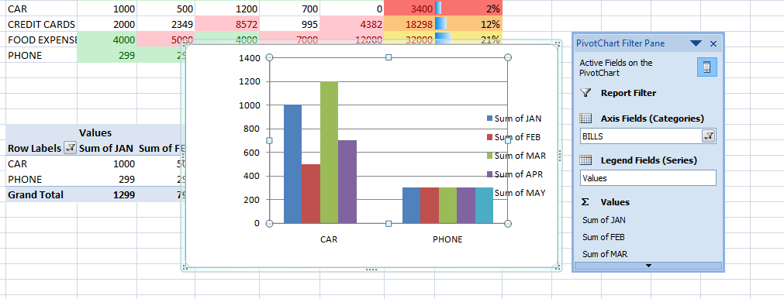

1. Final output: 